TOD – Multi- One-way Process flow document

- Customer will be given a similar screen where customer can select multiple trips at a maximum or 7 trips in one booking
  - Source
  - Destination
  - Date
  - Time
- when a passenger is adding the 2nd route then the 2nd route's origin point shall be the same ( as the first point destination) by default but pax wants to edit, he can edit it.

- When a passenger is adding the 2nd route then the pick up date / time shall not be less than the first route origin time and duration taken on the first trip else it will be invalid.

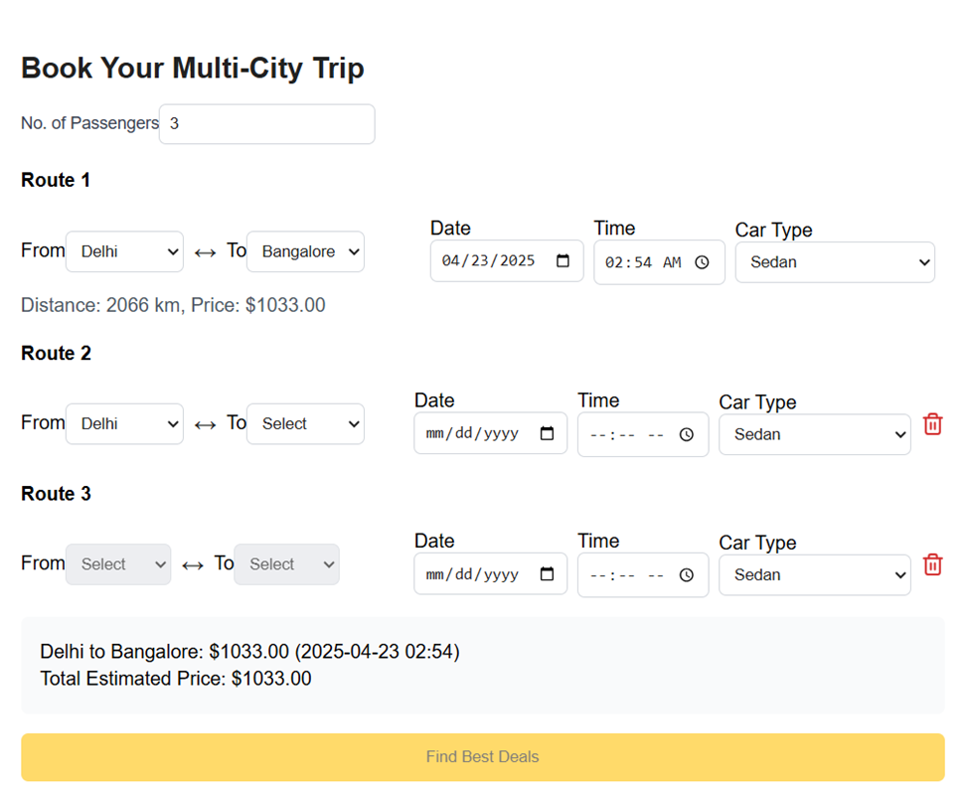

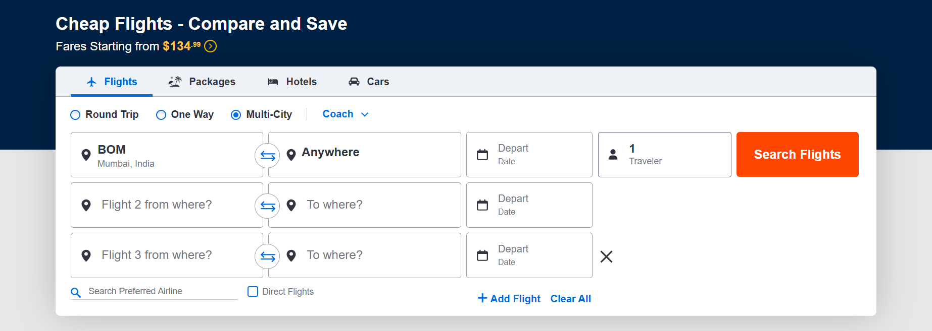
- On clicking search we will get a similar screen like below were
  - we will provide option for multiple types of vehicles available under the operational routes with the cheapest one’s on the top of the list
  - Routes where we do not have a operational city, we will need to leave a message that we do not operate at those locations.
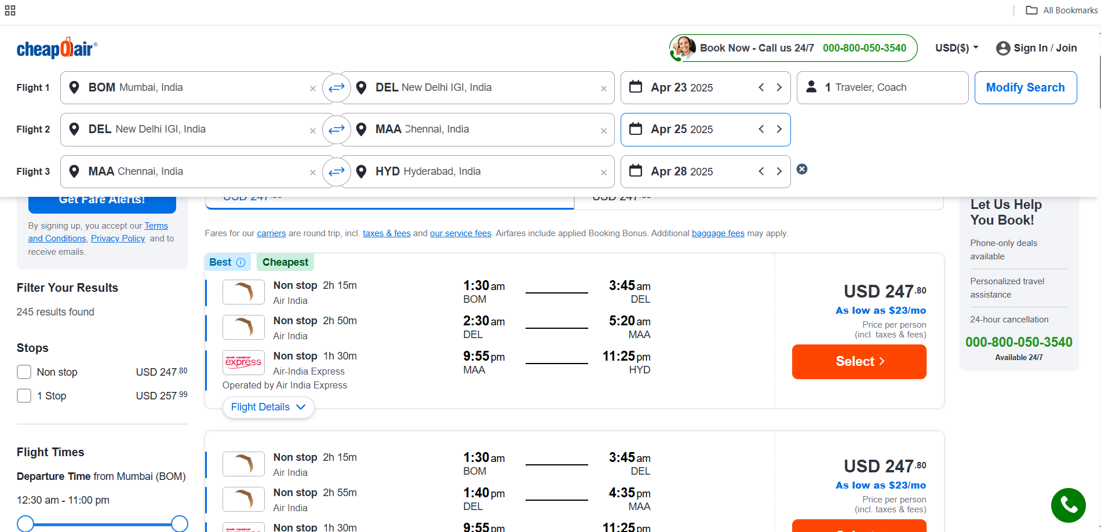
- Once customer chose the type of vehicle then

- we will take to next screen to add amenities available from the list of amenities from the operational cities database
- In case if Amenities are not available for any city, we will not show that option
- In this screen we will also have option to delete any route
- In case if customer wants to add a route, then we will have to give Modify option which will take back to the initial screen with already filled in details
- Once the customer finalizes the routes and amenities, we will take him to payment, and it will be completed as another trip.
- Multi one-way will have one master booking number, and which shall have sub booking ID for each sub booking
- Sub booking ID is like any other One-Way trip
- Customer can request Ops team to remove any sub trip; we will have provision to delete any route and ops team shall share the refund manually
- If customer want to add another route, it will be done as another one-way trip and ops center to handle it as another one-way trip
- Assignment is same as any other One-Way assignment

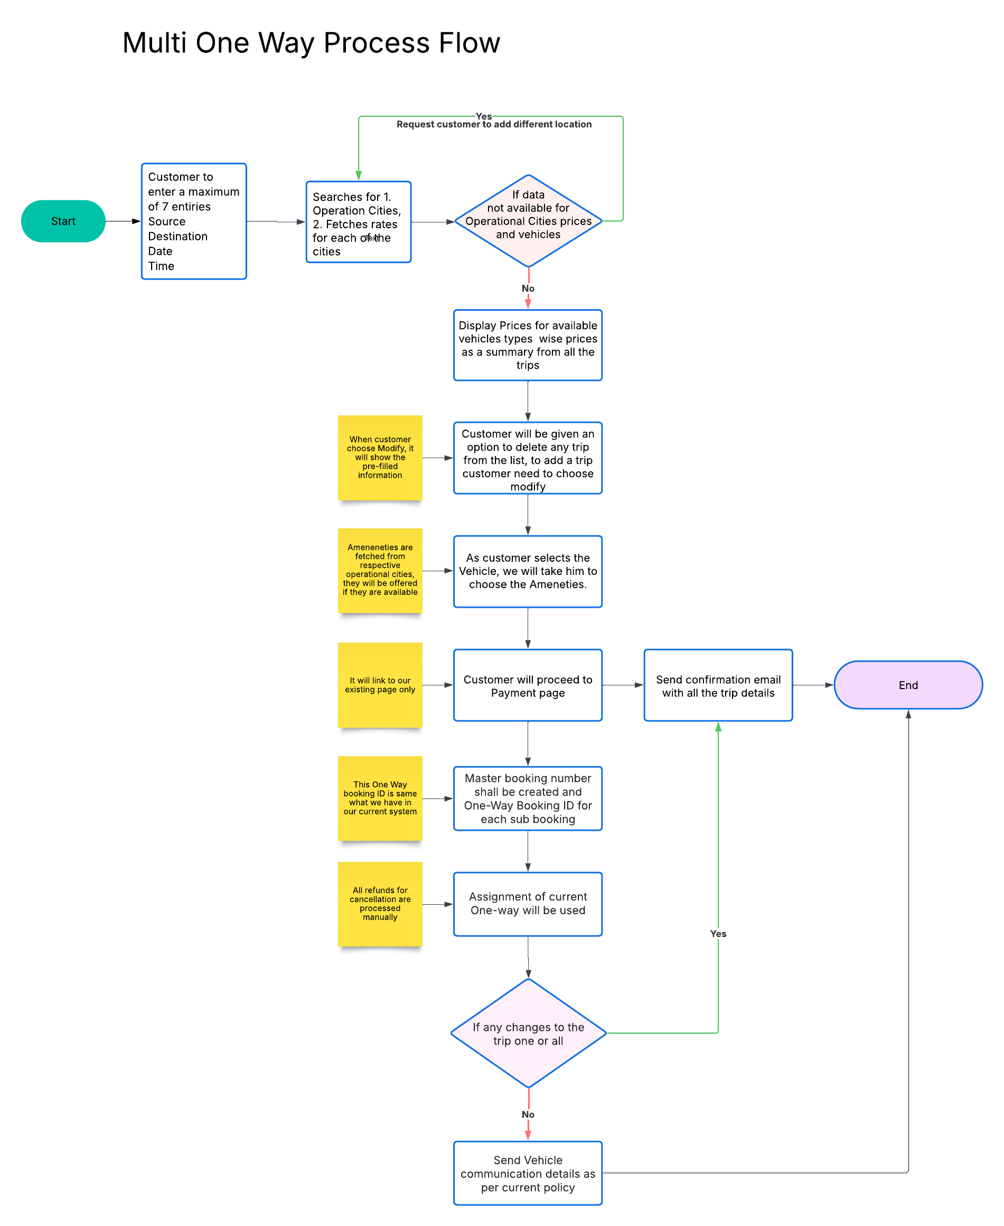
Screens Required:
Screen 1: Search and trip selection
Screen 2 : Summary and Payment
Screen 3: Ops Center - Multiple One-Way screen

